**FEA Model Development**

The wind turbine blade model used in this paper is based on a 9-meter research and development blade developed by Sandia National Laboratory known as the CX-100 [1-2]. The purpose of the CX-100 blade is to provide an inexpensive test platform for structural modeling and strength testing and is comprised of a unidirectional carbon-fiber laminate with a fiberglass skin. Using the airfoil geometry and composite layer specifications described in the CX-100 development reports, the geometry of the blade is created using the NuMAD (“Numerical Manufacturing and Design”) tool created by Sandia National Laboratories [3-4]. The NuMAD software serves to create the blade geometry based on input airfoil geometry data. Components of the blade (edges, root, spar caps, and shear web) are assigned composite material properties and geometry (layer orientation, quantity, and thickness).

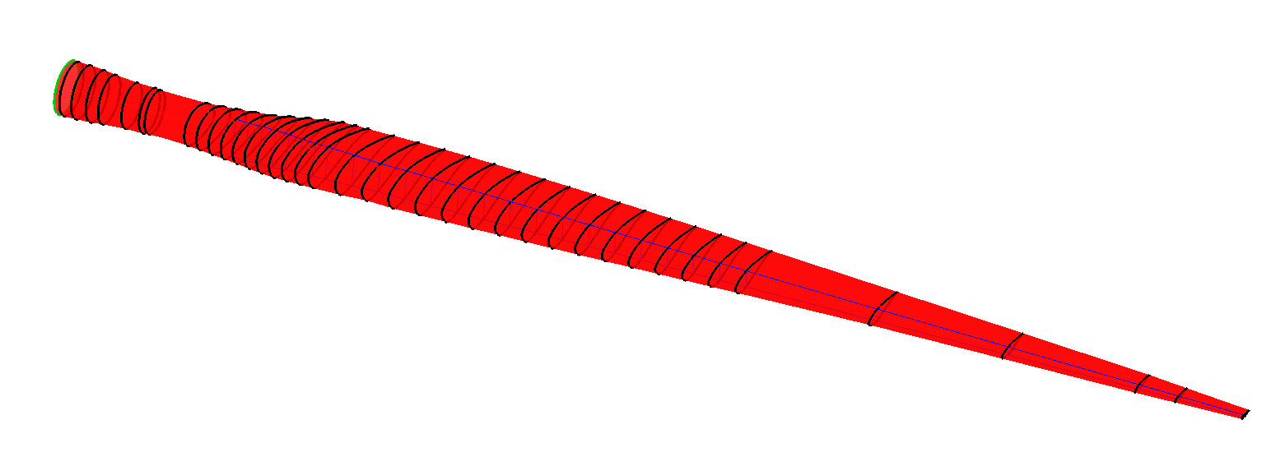

*Figure.* CX-100 blade model created in NuMAD for ANSYS input file generation and finite-element analysis.

The NuMAD software is then used to export the created blade model as an ANSYS input file to create the geometry, mesh the body with the appropriate material properties and geometries, and apply the boundary conditions. The model is composed of 8-node structural SHELL281 elements in layers to represent the composite material layers and that support the application anisotropic material properties. The study uses fixed-free boundary conditions where the root is simulated to be fixed to the turbine hub and the tip is free to measure deflection due to loading. Loading is applied to the blade tip as a 6,000N load in the flapwise direction based on measured turbine hub moments of the same blade design under high wind loads of approximately 54,000 N-m. The ANSYS input is modified accordingly to apply the loading, solve the model, and export the nodal displacements and rotations.

The generated ANSYS input file is included as a supplementary document to allow for analysis of the same blade model used in this paper, along with the accompanying NuMAD project file and required airfoil profiles and material database file.

References:

[1] Berry, D.S., “Blade System Design Studies Phase II: Final Project Report” (2008). Sandia National Laboratories Report SAND2008-4648.

[2] Berry, D.S. & Ashwill, T., “Design of 9-Meter Carbon-Fiberglass Prototype Blades: CX-100 and TX-100” (2007). Sandia National Laboratories Report SAND2007-0201.

[3] Berg, J.C. & Resor, B.R., “Numerical Manufacturing And Design Tool (NuMAD v2.0) for Wind Turbine Blades: User’s Guide” (2012). Sandia National Laboratories Report SAND2012-7028.

[4] Resor, B.R. & Paquette, J., “A NuMAD Model of the Sandia CX-100 Blade” (2012). Sandia National Laboratories Report SAND2012-9273.